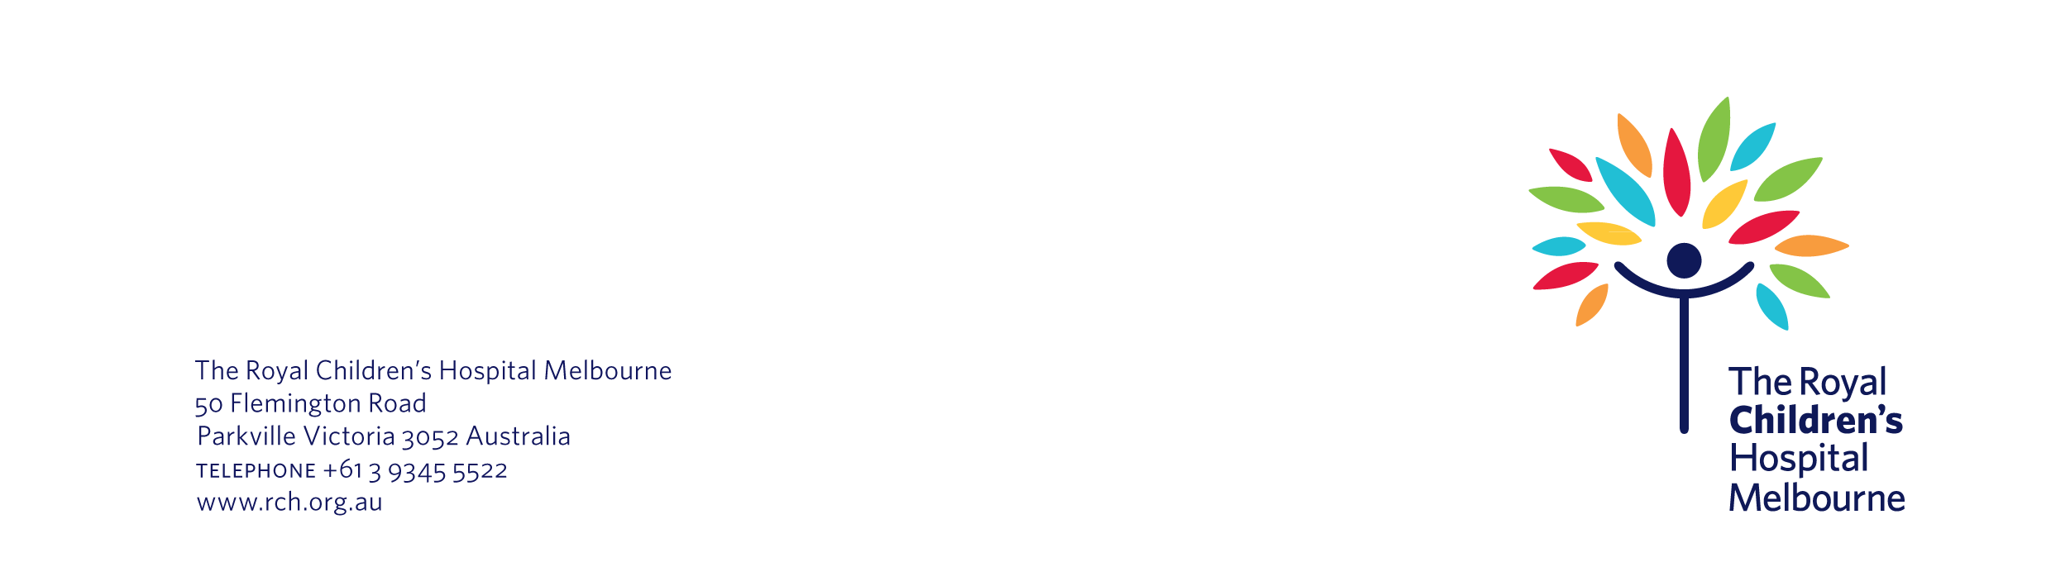
10 March 2025

Re | Thank you for taking part in our study
HREC number | 27117

Dear parent,

Thank you for taking part in the GAPS study.

As you may recall, the study started in 2021. We had 42 children take part. We tested a medication called dinomacotab – ‘the study drug’. We wanted to know whether the study drug could effectively treat children whose osteosarcoma had come back after surgery.

Unfortunately, we found that the study drug had no benefits for children with osteosarcoma. Therefore, we do not recommend this treatment for children with osteosarcoma. Instead, these children should continue to receive standard medical care.

We appreciate that this is a disappointing result. However, this study has advanced our understanding of treatment options for children with osteosarcoma.

If you have any questions, please contact me. You can reach me by phone on 3445 6789 or by email on Yousef.R.Khalil@rch.org.au.

We appreciate the time and effort that you and your child have put into the study.

Yours sincerely,

Yousef Khalil
Study Coordinator
GAPS study
The Royal Children’s Hospital

